Problem 1:

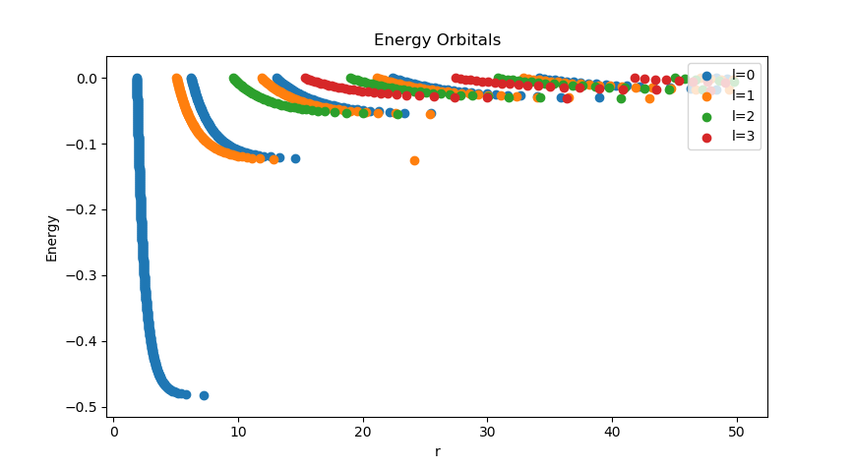
Plot the graph of e vs C using different plotting symbols for l = [0, 1, 2, 3].

What do the energies in this graph correspond to?

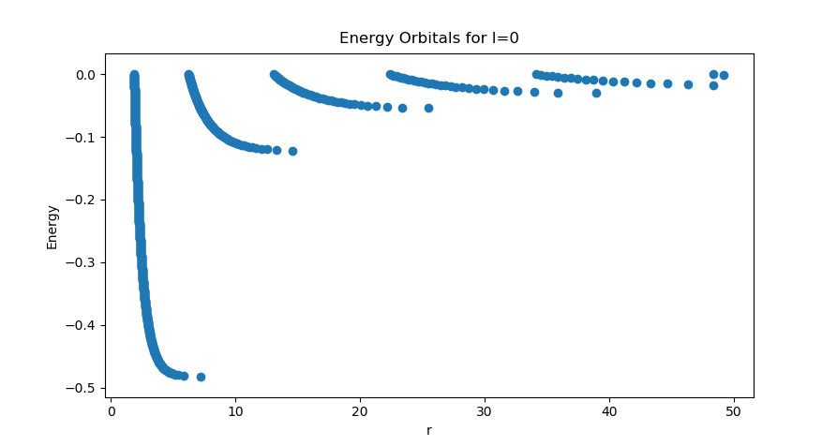
We are calculating wave amplitudes for a particle in a bound state as a function of energy and r, the distance from the potential well. This plot shows for a given energy, at what distances r the amplitude of the wave function drops to 0. Notice the trends of this graph for a single azimuthal quantum number, say l = 0
These distinct bands represent the different principal quantum numbers of the hydrogen atom; n=0 l=0, n=1 l=0, etc. As we vary the energy, it is clear there is some 'minimum' value of energy before there's no longer a solution for the given band. The asymptotic limit of each trend line hence returns the energy eigenvalue of the given quantum state.

Problem 2:

Repeating this calculation for the 3D harmonic oscillator: V (r) = r ∗ r/2, we find the following:
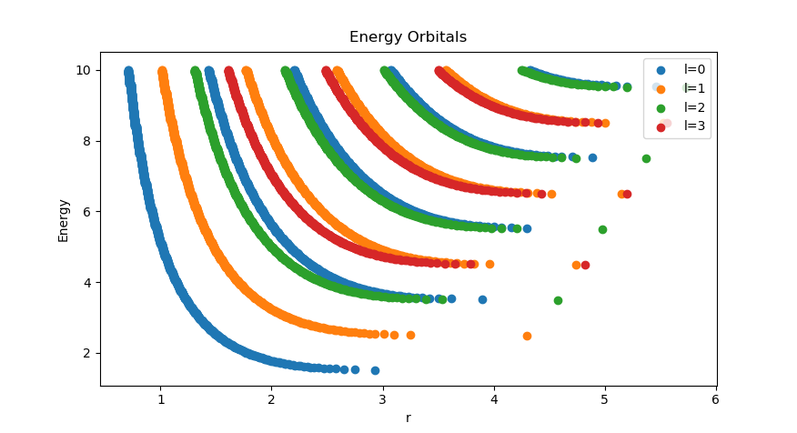

What is one thing they have in common in these two calculations?

Here we see the same unique bands popping up. Not surprising, as both graphs are solving for energy eigenvalues. Notice however that the states for a hydrogen atom are negative, while the 3-D well are positive.

Problem 3:

Determine the value of π to ≈ 14 digits by solving for the root of the equation f(x) = cos(x) = 0 using the second order Newton’s method. Use the initial guess of x = 1.5, x = 1, x = 0.5 and x = 0.25.

For an initial guess of x = 1.5, using Newton's method after only 2 iterations, the difference between my calculation and the value of pi was: 1.1097789354153065e-12.

For x = 1, this took 3 iterations with a difference of: -1.1826095658307167e-12

For x = .05, this took 5 iterations, but the difference was so small my computer reads a 0.

for x = .25, the difference between my calculation and (3/2)pi (the zero point of this starting position), took only 4 iterations with a difference of -1.5987211554602254e-13

Problem 4:

Use the Killingbeck method as presented in class to solve for the eigenvalues of the hydrogen atom; Plot all energy values as a function of dr from 0.01 to 0.1:
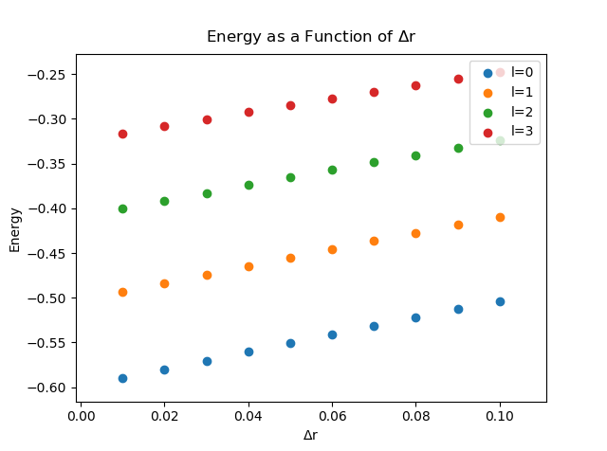
Determine the lowest energy levels of l = 0,1,2,3

From the trends, it appears the lowest level of l = 0 for example, approaches -0.5, which is what we expect.

